El propósito del Plan de Gestión de Datos (PGD) es proveer un análisis de los principales elementos de la política de gestión de datos que se usarán por los solicitantes en relación con todos los datasets que serán generados por el proyecto. El PGD no es un documento fijo, sino que va evolucionando durante la vida del proyecto.
Ver Ejemplos

Project title and brief description:
Plan name
Project identifier | -
Project coordinator | -
Contact details of the coordinator
Contact details of the author/s of the Data Management Plan

Título del proyecto , datos de contacto-identificación y breve descripción:

What data will be produced?/¿Qué datos se producirán? (Tipos)

Origen de los datos

Ayuda

How will data be documented and described?/¿Cómo se documentarán y describirán los datos? Ayuda

How will data be structured and stored?/¿Cómo se estructurarán y almacenarán los datos? Estándares usados. Ayuda

Are there any ‘special’ requirements for your data?/¿Existe algún requisito “especial” para sus datos? Ayuda

What are the plans for data sharing and access?/¿Cuáles son los planes para el intercambio de datos y para el acceso a los mismos? Ayuda

What are your main data challenges? Who can help? /¿Cuáles son sus principales retos en lo que concierne a los datos? ¿Quién puede ayudar? Ayuda

Who is responsible for managing the data?

What resources (will you need?
- Posibles Grupos de interés respecto a sus datos

¿Quién se encarga de la gestión de los datos? ¿Qué recursos necesitará (ECONÓMICOS Y TÉCNICOS? Ayuda

No olvide revisar y actualizar su plan de gestión de datos de forma regular.

Plan Gestión de Datos – Hoja de ayuda
Todo puede convertirse en datos de investigación si se utiliza con fines de investigación - los datos no son sólo números en una hoja de cálculo. Piense creativamente sobre los materiales que está utilizando y produciendo: lo que podría compartirse con otros investigadores que estén interesados en su trabajo; ¿Qué podría reutilizarse para producir nuevos conocimientos? Cualquier evidencia o material que sustente o arroje luz sobre sus hallazgos, sus publicaciones académicas, su tesis o su proyecto pueden ser considerados datos de investigación

What data will be produced?/ ¿Qué datos se producirán?
¿Qué datos físicos se estudiarán? (ej. Artefactos, muestras, archivos de papel, etc.)
¿Qué datos digitales se generarán? (ej. Notas de campo, imágenes, hojas de cálculo, entrevistas en audio, datos de sondeo, bibliografía comentada, etc.)
¿Qué formatos de archivo y qué software utilizará?

How will data be documented and described? / ¿Cómo se documentarán y describirán los datos?
¿Serán sus datos entendibles por terceras personas? Documéntelos. Asegúrese de indicar claramente los valores de las tablas y hojas de cálculo.

¿Qué información se recogerá sobre la metodología de acopio de los datos?

¿Es importante para la investigación el ser reproducible? por qué/por qué no si lo fuera, ¿Qué documentación adicional o qué indicadores se requerirán?
¿Creará programas? ¿Escribirá código? ¿Dónde estarán documentados y almacenados para uso futuro?

How will data be structured and stored? / ¿Cómo se estructurarán y almacenarán los datos?
Calcule qué cantidad de datos producirá a lo largo del tiempo - ¿Tiene suficiente almacenamiento?

Está Vd. haciendo pleno uso del almacenamiento protegido proporcionado por la Universidad?¿Cómo se guardarán los datos generados en el almacenamiento seguro de la Universidad?

¿Tiene alguna normalización lógica de la denominación de archivos y estructura de directorios?

¿Cómo gestionará el versionado para que se pueda identificar la versión actual de los documentos/datos?

Are there any ‘special’ requirements for your data? / ¿Existe algún requisito “especial” para sus datos?
¿Son datos confidenciales? ¿Están debidamente almacenados y encriptados?
¿Despersonalizará sus datos?
¿ Establece el financiador de la investigación requisitos concretos para la gestión e intercambio de datos?
¿Habrá que destruir algunos datos? ¿Cuándo y cómo?

What are the plans for data sharing and access in the short and long term?/ ¿Cuáles son los planes para el intercambio de datos y para el acceso?
¿Ha sopesado el intercambio de datos con sus colaboradores/supervisor de investigación?

Si su investigación involucra a personas, ¿ha obtenido el consentimiento debido para compartir datos?

¿Se pueden liberar sus datos de forma inmediata, o están sujetos a embargo (retrasar el acceso )?

¿Qué datos conservará? ¿Quién lo decide?

¿Estarán abiertos los datos para todo el mundo o habrá restricciones de acceso?

¿Durante cuánto tiempo estarán/deberán estar los datos disponibles?

¿Utilizará un repositorio de datos?¿Cuál?

What are your main data challenges? Who can help? ¿Cuáles son sus principales retos en lo que concierne a los datos? ¿Quién puede ayudar?
¿Necesita formación o apoyo? ¿Dispone de ello?

¿Qué políticas universitarias o de otro ámbito son aplicables a su proyecto? ¿Las ha leido y comprendido?

Who is responsible for managing the data? What resources will you need? ¿Quién se encarga de la gestión de los datos? ¿Qué recursos necesitará?
¿Quién es el responsable de los datos en las distintas etapas de su ciclo vital?

¿Hay suficientes recursos disponibles (habilidades, personas, almacenamiento, tecnología) para lanzar su plan?

EJEMPLO 1:
Project Name Drosophila Genetics - BBSRC Example
Description This project will investigate the role of Polo kinase in metaphase to anaphase
transition in Drosophila melanogaster.
Funder Biotechnology and Biological Sciences Research Council
Institution University of Glasgow
Data areas and data types
Outline the volume, type and content of data that will be generated e.g. experimental measurements, models, records and images
This project will generate three main types of raw data.
1. Images from transmitted-light microscopy of giemsa-stained squashed larval brains.
2. Images from confocal microscopy of immunostained whole-mounted larval brains.
3. Western blot data.
Measurements and quantification of the images will then be recorded in spreadsheets.
Micrograph data is expected to total between 100GB and 1TB over the course of the project.
Scanned images of western blots are expected to total around 1GB over the course of the
project.
Other derived data (measurements and quantifications) are not expected to exceed 10MB.
Standards and metadata
Outline the standards and methodologies that will be adopted for data collection and management, and why these have been selected
All samples on which data are collected will be prepared according to published standard protocols in the field. All microscopes used for sample examination are serviced and recalibrated regularly. All Drosophila lines used in experiments are checked periodically for phenotypic markers. Drosophila are maintained in live culture according to standard methods in the field.
Files will be named according to a pre-agreed convention. The dataset will be accompanied by a README file which will describe the directory hierarchy and filenaming convention.
Each directory will contain an INFO.txt file describing the experimental protocol used in that experiment. It will also record any deviations from the protocol and other useful contextual information.
Microscope images capture and store a range of metadata (field size, magnification, lens
phase, zoom, gain, pinhole diameter etc) with each image.
This should allow the data to be understood by other members of our research group and add contextual value to the dataset should it be reused in the future.
Relationship to other data
State the relationship to other data available in public repositories
This dataset will provide a novel characterisation of Drosophila Polo kinase mutants
documented in the Flybase database. To the best of my knowledge, no other study has
perturbed the metaphase to anaphase transition in these mutants, then examined the
phenotypes seen in mitosis.
Secondary Use
Outline the further intended and/or foreseeable research uses for the completed
dataset(s)
The confocal and transmitted light images generated in this work may well be of use in the future. It is entirely possible that another study would want to measure a different aspect of mitosis in Drosophila (both the wild-type controls and the mutants) treated as per the protocols in this study.
I cannot see the western blot data being of future use.
Methods for data sharing
Outline the planned mechanisms for making these data available, e.g. through
deposition in existing public databases or on request, including access Mechanisms where appropriate
Datasets from this work which underpin a publication will be deposited in Enlighten: Research Data, the University of Glasgow’s institutional data repository, and made public at the time of publication. Data in the repository will be stored in accordance with funder and University data policies. Files deposited in Enlighten: Research Data will be given a Digital Object Identifier (DOI) and the associated metadata will be listed in the University of Glasgow Research Data Registry and the DataCite metadata store. The retention schedule for data in Enlighten:
Research Data will be 10 years from date of deposition in the first instance, with extensions applied to datasets which are subsequently accessed. This complies with both University of Glasgow guidance and funder policies.
Enlighten: Research Data is backed by commercial digital storage with is audited on a twiceyearly basis for compliance with the ISO27001 Information Security Management standard.
The DOI issued to datasets in the repository can be included as part of a data citation in
publications, allowing the datasets underpinning a publication to be identified and accessed.
DOIs will also be linked with appropriate records in Enlighten: Publications, the University’s publication repository, to enhance visibility of datasets.
Metadata about datasets held in the University Registry will be publicly searchable and
discoverable and will indicate how and on what terms the dataset can be accessed.
Information about datasets from the Registry will be displayed on researcher profile pages on the University of Glasgow webpages which will also increase the visibility of the datasets.
Proprietary data
Outline any restrictions on data sharing due to the need to protect proprietary or
patentable data
It is not anticipated that this study will generate any patentable data or proprietary data which would have to be protected.
Timeframes
State the timescales for public release of data
Data will be made available at the point of publication of the associated paper or publication.
Formats
State the format of the final dataset
Images will be stored as .tif
Data in spreadsheets will be stored as .csv
Data in freetext documents will be stored as .txt.
These formats are platform agnostic and should support future access and reuse.
Any data which has to be stored in a proprietary format will have the necessary software
(including version number) noted in the associated INFO.txt file.

Plan
EJEMPLO 2: Data Management Plan: Opening access to economic data to prevent tobacco related diseases in Africa
Data Collection
What data will you collect or create?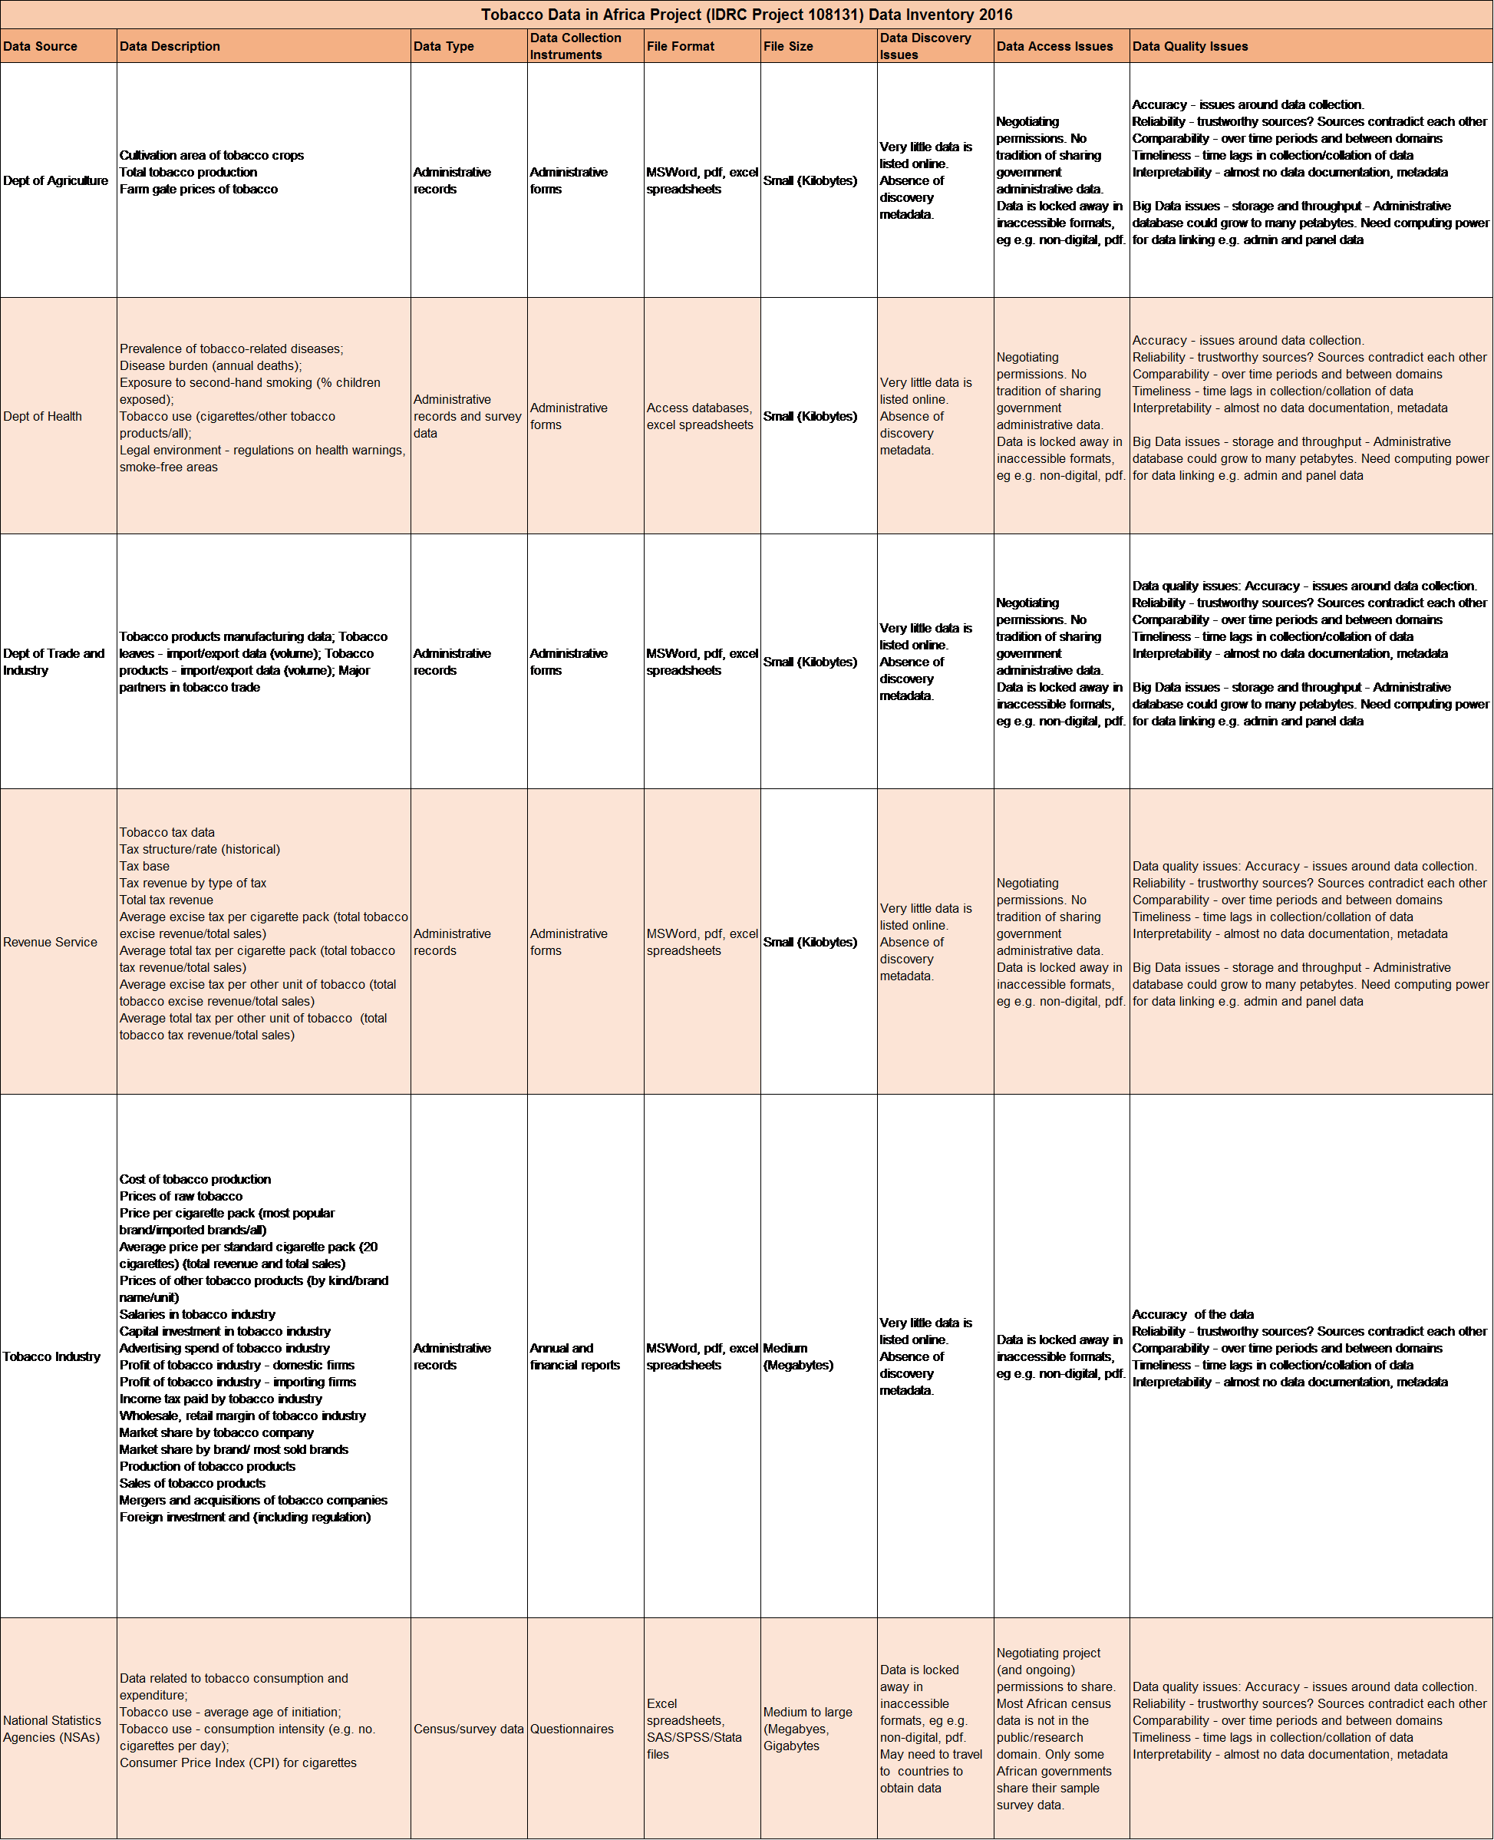How will the data be collected or created?
Data Collection methods
1. Desk-based search of official websites of project countries
This will involve searching websites of government departments These will include data
on:
1. Tobacco production (Departments of Agriculture)
2. Prevalence of tobacco-related diseases, and tobacco-related morbidity and
mortality (Departments of Health)
3. Tobacco taxation (Internal Revenue Services)
4. Tobacco products manufacturing, tobacco imports/exports (Departments of Trade
and Industry)
5. Tobacco usage, from Surveys by National Statistics Agencies (NSAs). In South
Africa unit record administrative data from government departments, repackaged as
research datasets, are also shared by the NSA. If data collection instruments
(administrative forms) used to collect the data are available on these sites they can
provide useful information on the data.
2. Desk-based search of websites of International Development Organisations
This desk-based study will allow us to discover tobacco data on project countries that has
been collected by international organisations. The will include the websites of the
international DHS Program and UN bodies such as the World Health Organisation
(WHO). From this a "question bank" will be created of useful variables and the datasets
where these can be found.
2. Desk-based search of industry websites
The third component of our desk-based research will involve examing online records of the
tobacco industry. From these we hope to obtain data on: Cost of tobacco production, and
profits, in the industry, prices of raw tobacco and tobacco products, salaries, capital and
foreign investment, mergers and acquisitions, advertising spend, and regulations in the
industry
3. Approaches to data holders
We will create metadata on our platform for surveys already shared by others online. Our
desk search may also reveal the existence of datasets with a tobacco data components but
which are not in the public domain. In these cases we will approach the relevant research
projects in the project countries to release this data and allow the Project to host this on
their Open Data portal. This may be a fraught process but any challenges and successes
can be written up to inform our future work.
4. Own surveys
The project has already crowd-sourced data on current prices of tobacco products in two
project countries. This may be expanded during the course of the project to all project
countries. We will upload and share the metadata and data from these surveys.
Documentation and Metadata
What documentation and metadata will accompany the data?
Supporting documents
Data collection and data analysis documents will be shared along with the data files, where
available. Forms used for collecting administrative data will be shared with administrative
datasets. Data collection instruments (questionnaires, diaries) will be made available with
the survey data. Code lists used in collecting the data will also be provided. Final reports
from data collection projects will also be shared, where available.
Metadata
Each dataset will have a metadata record to help data users analyse the data. This
metadata record will be created during examination of the data and data collection
instruments. It will include information gathered on the dataset during the data collection
process. This documentation can be an invaluable source of provenance and usage
information for those analysing the data. Notes on data quality will form part of the
metadata record. Metadata will be created according to the Data Documentation Initiative
(DDI) international metadata standard, using Nesstar Publisher, which is free data markup
software for the creation of XML-compliant metadata according to the DDI standard.
Ethics and Legal Compliance
How will you manage any ethical issues?
The administrative data we will collect will mostly be in the public domain, in the form of
reports and other records from government departments. The survey data we will collect
will be anonymised data already shared with researchers, although not always online. The
industry data will be data made available to shareholders and the public. We are adding
value by bringing these sources together and providing a means for researchers to easily
discover and download these data.
However, we will endeavour to make data available that is not yet in the public domain. In
these cases, we will ensure that:
1. We have the necessary permissions from data owners to make these data open.
2. The data is suitably anonymised, to protect respondent confidentiality and privacy
3. We take national laws on sharing data across borders into account. Where such
restrictions exist, we will be unable to host this data.
4. We work with all stakeholders to ensure agreement on what will be shared, how,
and with whom.
4 Woolfrey L
How will you manage copyright and Intellectual Property Rights (IPR) issues?
The government data we will collect is not subject to IPR. The tobacco industry data we will
collect will be public records. We will therefore not publish information that would
compromise any IP rights. However, we will check each traunch of data we obtain, to
ensure we have permission to pass the data on to third parties.
Storage and Backup
How will the data be stored and backed up during the research?
The data would be stored on a server managed and backed up by the University of Cape
Town's Commerce IT Department. Curation of the data will be the responsibility of
DataFirst's Research Data Service. DataFirst is a technical partner on the Project. Each
preservation dataset will consist of data files, document files, metadata files, and any
programme files used in creating the data files. Data Service staff will be responsible for
adding data updates to datasets. We will also handle version control to ensure the most
recent and accurate data files are published, and provide tombstone citations to earlier
versions for verification or replication of research which may cite these supercede versions
of the data.
How will you manage access and security?
Access to the server hosting the preservation datasets will be password controlled.
Passwords will be allocated by the Commerce IT manager only to Data Service staff.
Server software will monitor data security and integrity.
Selection and Preservation
Which data are of long-term value and should be retained, shared, and/or
preserved?
Criteria for preservation will be:
1. Data is tobacco-related
2. Data covers project countries
3. Data is accurate and reliable (we will undertake quality audits to determine this)
4. Data is unit record data (not aggregated but available at the level at which it was
collected)
5. Data is not readily available from another repository
Retention:
It is difficult to predict what data has long-term value. Our policy will be to store unit record
tobacco data indefinitely. As these datasets grow, so will their value over time. Time-series
data will continue to be useful for economic and health policy research in the long term.
Sharing:
Because we aim to establish an Open Data portal, all data retained/preserved will also be
shared. The Project's policy is aligned to DataFirst's policy: We do not archive data which
cannot be shared with researchers in some form and at some access level.
What is the long-term preservation plan for the dataset?
There will be numerous datasets. Our long term preservation plan for the Project's data
holdings depends on the sustainability of DataFirst's Research Data Service. The service
was established in 2001 and is a unit at the University of Cape Town, a well- funded and
well-established university in South Africa. Our sustainability prospects are therefore good.
Data Sharing
How will you share the data?
The data will be shared as discrete datasets (by country, year, data source). DataFirst
hosts and shares data via an online dissemination platform, based on the National Data
Archive Open Source software developed by the World Bank's Development Data Group.
The platform provides a number of data access options. The Project's data will be shared
as Public Use data. That is, researchers will need to register on our site and say for what
purpose they will use the data, but access will be immediate and automatic, with no vetting
of use. The usage information we collect will be to support service improvements.
The data will be shared in a number of formats, includind excel spreadsheets, and data
files in the commonly used statistical analysis programmes (SPSS, Stata). We will also
make the data available as .csv files, in line with Open Data requirements.
Are any restrictions on data sharing required?
We aim to share the tobacco data we collect as public access data. We do not aim to
support research-use only requirements, as this is counter to Open Data principles. Policy
research, academic research, business analysis, and private sector innovation all need
good data, and countries benefit from informed decision-making in all these spheres.
6 Woolfrey L
Responsibilities and Resources
Who will be responsible for data management?
The Manager of DataFirst will be responsible for curating the Project's data. This is in line
with the project proposal for DataFirst to be funded to provide technical support. DataFirst's
Manager has 25 years' experience in managing research data and working with data users.
Skills learned from undertaking data rescue projects in South Africa will also be useful in
assisting with data collection activities.
What resources will you require to deliver your plan?
Funding for data collection as been budgeted for in the Project. This may need to include
funding to travel to project countries and negotiate with data collectors in government and
academia to release their data, and allow its reuse. Funding has been provided for a
Project Manager. The Project Manager is responsible for conducting online data audits and
downloading data, and populating the database which DataFirst's Manager will curate. This
will be a time- and labour- intensive task and more staff hours may need funded for this.

